Title of the Document

<Online Exam System Project Functional Specification Document>

Author: <Malcolm Li>
Last Updated: <Jul 22, 2016>

Document History
Date | Author | Summary of Change | Note
Jul 20, 2016 | Malcolm Li | Wrote 4 user cases.
Jul 21, 2016 | Malcolm Li | Increase 17 user cases
Jul 22, 2016 | Malcolm Li | Increase the description of the use case's brief.
<Table of Contents>

Overview 5
Use Case Diagrams 5
Use Case Scenarios 7
UC001 <Login System> 7
UC002 <Create User> 10
UC003 <View User List> 14
UC004 <Create Question> 16
UC005 <Delete Question> 19
UC006 <Logout System> 22
UC007 <Update User> 22
UC008 <Delete User> 22
UC009 <Change Password> 22
UC010 <Update Question> 22
UC011 <View Question List> 23
UC012 <View Exam List> 23
UC013 <Take Exam> 23
UC014<Submit Exam> 23
UC015 <Check All Exams> 23
UC016 <View Student List> 24
UC017 <Review All Fnished Exams> 24
UC018 <Review all statistical information> 24
UC019 <Edit User Profile> 24
UC020 <Auto Submit Exam> 24
UC021 <Correct Exam Question> 25
Non-functional Requirements 25
System Installation Requirements 25
Runtime Requirements 25
I18N and L10N Requirements 25
Documentation Requirements 25
Other Non-functional Requirement 25

Overview
Online Exam System has the client and web system. The web system provides user management, question’ management and exam management functions. The user with SysAdmin can manage all users including create, edit, delete user. The user with ContentAdmin can manage all questions and exams. The client System has two role Studnt and Teacher.Student can take one of not finished exams. Student can see his all exams. Teacher can see the student list, and review all finished exam and statistics information.

Use Case Diagrams
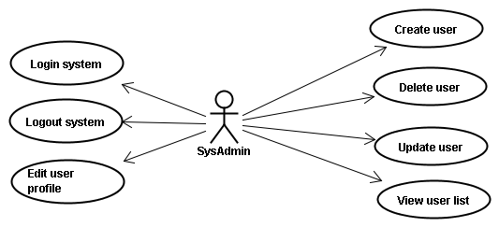
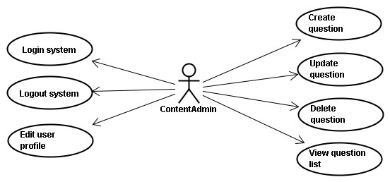

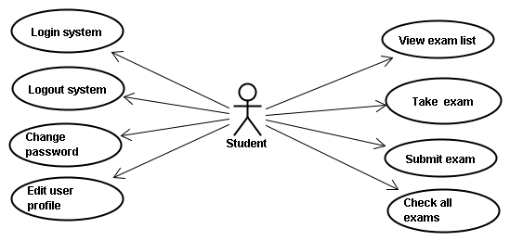
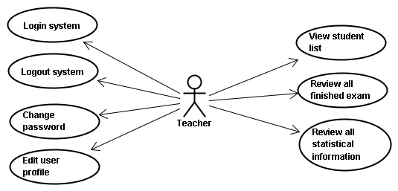
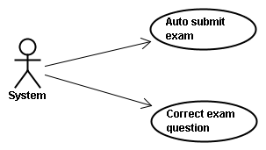
Use case id | Use case name
UC001 | Login system
UC002 | Create user
UC003 | View user list
UC004 | Create question
UC005 | Delete question
UC006 | Logout system
UC007 | Update user
UC008 | Delete user
UC009 | Change password
UC010 | Update question
UC011 | View question list
UC012 | View exam list
UC013 | Take exam
UC014 | Submit exam
UC015 | Check all exams
UC016 | View student list
UC017 | Review all finished exams
UC018 | Review all statistical information
UC019 | Edit user profile
UC020 | Auto submit exam
UC021 | Correct exam question

Use Case Scenarios

UC001 <Login System>
Brief: User open the login page, and fill in the user name and password. Then user click the submit to login the system.

Actor: SysAdmin, ContentAdmin, Student, Teacher

Pre-condition: none.

Mock Up UI:
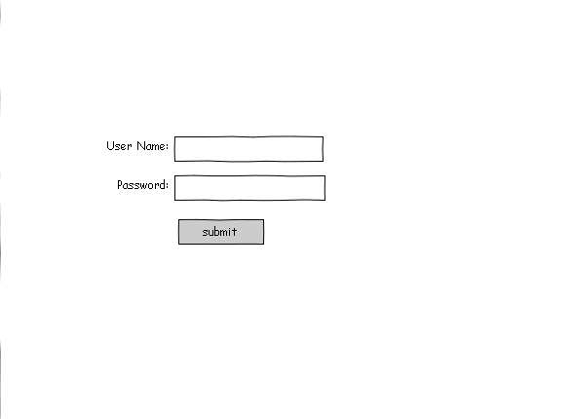
Diagram 1
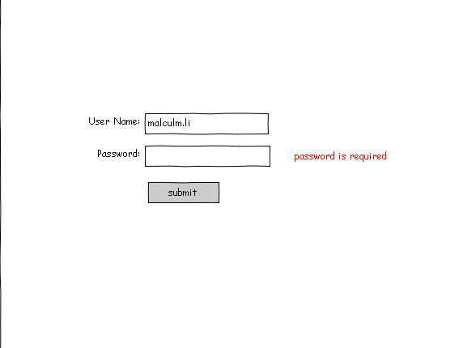
Diagram 2
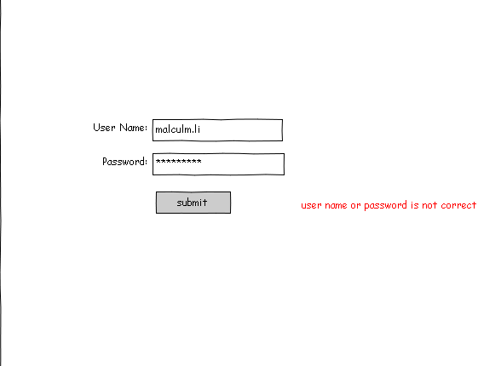
Diagram 3
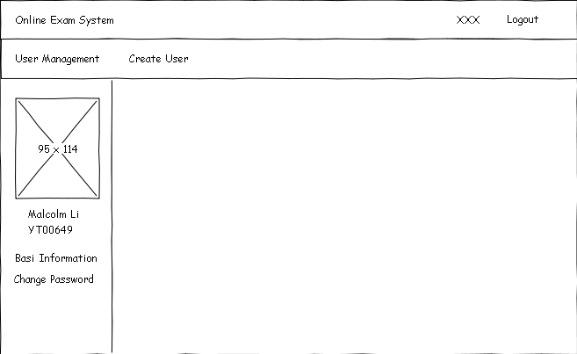
Diagram 4

General Workflow:

User Operation | System Response
1: User open the login page. | 2: System display the page(Diagram 1).
3: User fill in incomplete information, and click the “submit” button. | 4: System will validate data. System find the information is incomplete, System will prompt the red information (Diagram 2).
5: User fill in the error user name or password, and click the “submit” button. | 6: System will validate data. System find the user name or password is error and System will display the page(Diagram 3).
7: User fill in the correct user name and password, and click the “submit” button. | 8: System will validate data. If username and password is ok, System will display the page(Diagram 4).
Comment:
validate data

UC002 <Create User>
Brief: SysAdmin open the user management page. And SysAdmin fille in the form include(user name, chinese name, id, gender, role type,etc). SysAdmin click the “create” button to create user, or click the “cancle” button to cancle this operation. And back to the user management page.

Actor: SysAdmin

Pre-condition: SystemAdmin login the system.

Mock Up UI:

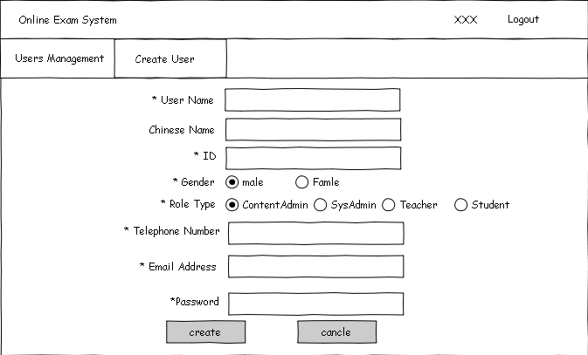
Diagram 1
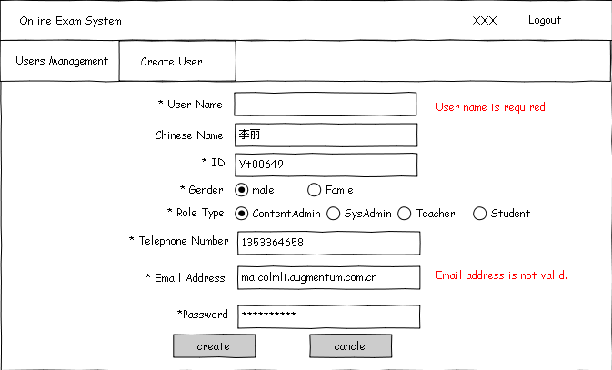
Diagram 2

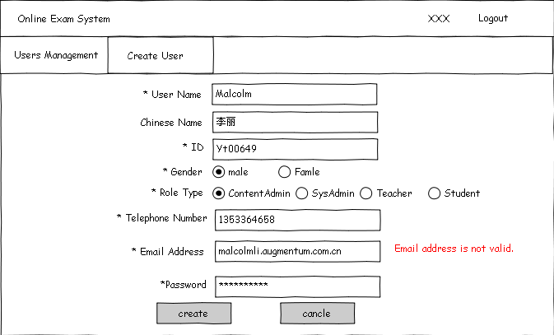
Diagram 3
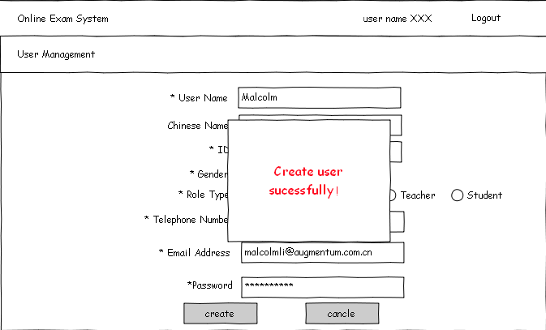
Diagram 4
Diagram 5

General Workflow:

User Operation | System Response
1: User click the “create user” tab in the page. | 2: Server will display the page(Diagram 1).
3: User fill the form.
4: User click “create” button. | 5: System will validate data.  5.1: If system find the information is incomplete, system will show a red message(Diagram 2).  5.2: If system find the information not correspond the requirement, system will show a red message(Diagram 3).  5.3: If the information is ok, system will save the information and display a successful window(Diagram 4).
6: User click “cancle” button. | 6: System will display the main page(Diagram 5).
Comment:
validate data

UC003 <View User List>
Brief: SysAdmin open the user management page. And SysAdmin can view the all user list. SystemAdmin also can view user list by input the keyword and click the “search” button. And the result will be updated in this page.

Actor: SysAdmin

Pre-condition: SystemAdmin login in the system.

Mock Up UI:
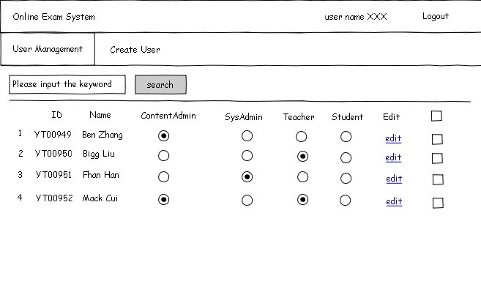
Diagram 1
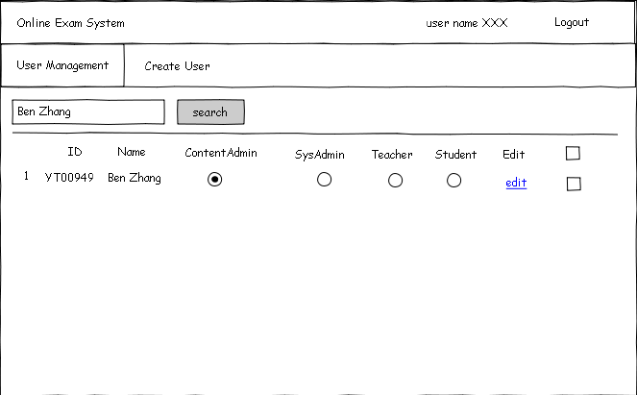
Diagram 2
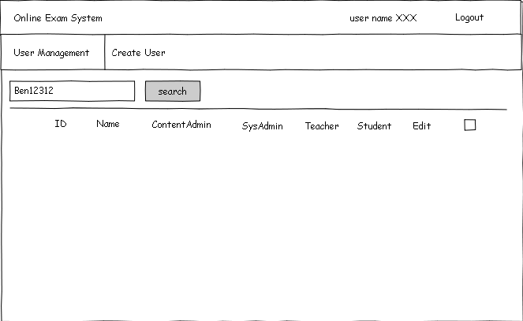
Diagram 3
General Workflow:

User Operation | System Response
1: User click the “User Manager” tab in the page | 2: System display the user management page(Diagram 1)
3: User click the fill in the keyword on search text and click the “search” button. | 4: If system find the related result to the keyword, system will display the result(Diagram 2).Otherwise，system will display the page(Diagram 3).
Comment:
validate data

UC004 <Create Question>
Brief: ContenAdmin open the question management page. And ContenAdmin click the “create question” link to open the create question page. Then ContentAdmin fill the question’s id, question and answer. ContentAdmin can click the “create” button to create a question. ContentAdmin can click the “cancle” button to cancle this operation and back to the question management page. The question is a single choice with 4 optional answers(A, B, C, D).

Actor: ContenAdmin

Pre-condition: ContentAdmin login the system.

Mock Up UI:
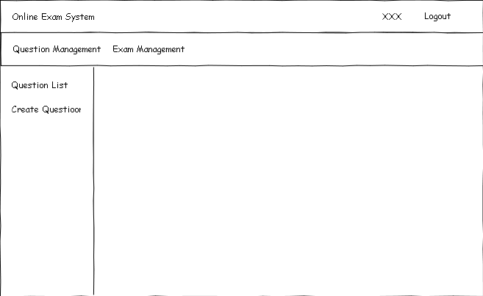
Diagram 1
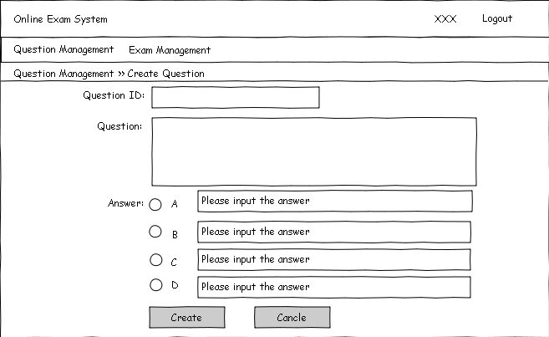
Diagram 2
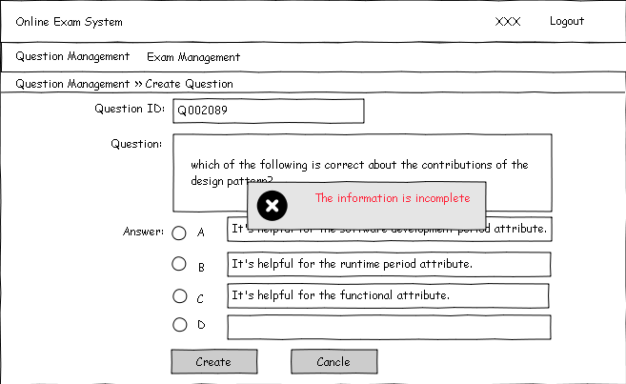
Diagram 3
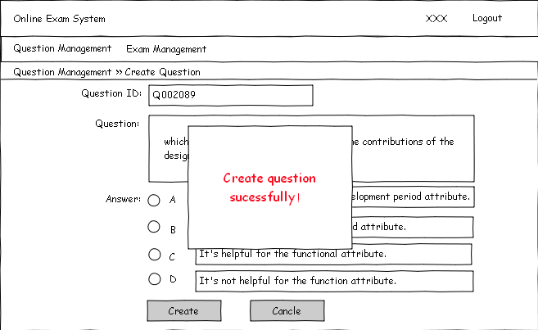
Diagram 4
General Workflow:

User Operation | System Response
1: User login the system. | 2: System display the question management page(Diagram 1).
3: User click the create question link. | 4: System display the create question page(Diagram 2).
5: User fill in the form.
6: User click the “Create” button. | 7: System will validate the form.  7.1: If the information is not complete, System will pop up a error window(Diagram 3).  7.2: if the information is complete, system will pop up a successful window(Diagram 4).
8: User click the “Cancle” button. | 9: System will display the question management page(Diagram 1).
Comment:
validate data

UC005 <Delete Question>
Brief: ContentAdmin can delete question that not be used in exam.

Actor: ContentAdmin.

Pre-condition: ContentAdmin open the question management.

Mock Up UI:
Diagram 1
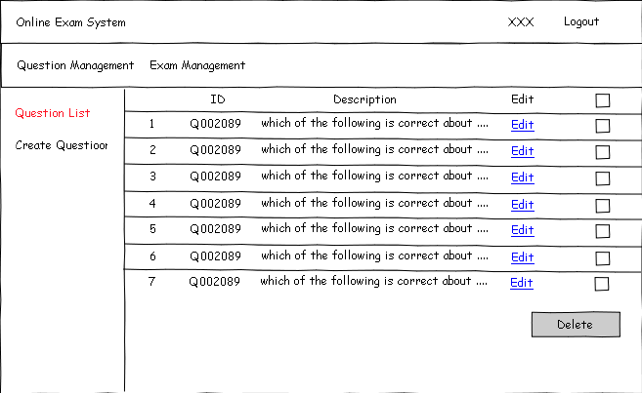
Diagram 2
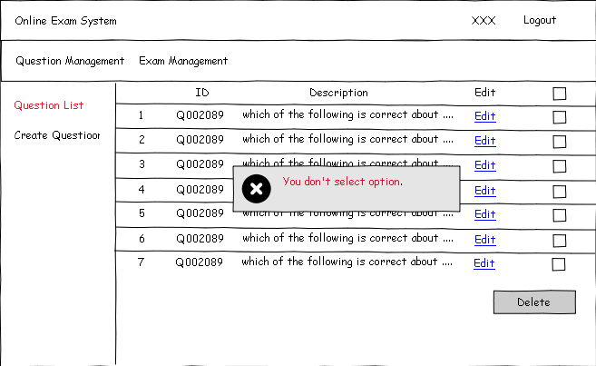
Diagram 3
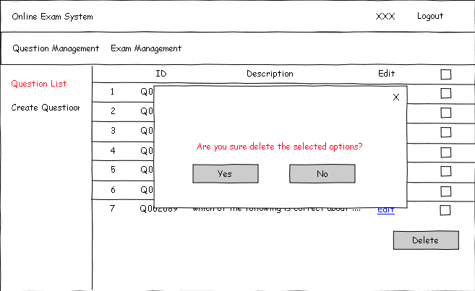
Diagram 4
General Workflow:

User Operation | System Response
1: User login the system. | 2: System display the question management page(Diagram 1).
3: User click the question list link. | 4: System display the question list page(Diagram 2).
5: User click the “Delete” button, but not select option. | 6: System will validate the information, and pop up a error window(Diagram 3).
7: User select some options, and click the “Delete” button. | 8: System will validate the information. and pop up a prompt window(Diagram 4).
9: User click the button. | 10.1: If user click the “Yes” Button, system will delete the selected options.  10.2: If user click the “No” Button, system will canclel this operation.
Comment:
validate data

UC006 <Logout System>
Brief: When user login the system, user can logout from system, and user's information will be cleaned up. And user will back to the login page.

Actor: ContentAdmin, SysAdmin, User, Teacher.

Pre-condition: User login system.

UC007 <Update User>
Brief: SysAdmin open the user management page. SysAdmin click the user's link to update. Then SysAdmin fill in the user name chinese name, gender etc. SysAdmin click the “save” button to save the information. SysAdmin click the “cancle” button to cancle this operation and back to the user management page.

Actor: SysAdmin.

Pre-condition: SysAdmin open the user management.

UC008 <Delete User>
Brief: SysAdmin open the user management page. And SysAdmin check the user who will be deleted. Then SysAdmin click the “delete” button to delete the checked users.

Actor: SysAdmin.

Pre-condition: SysAdmin open the user management.

UC009 <Change Password>
Brief: Then user click user's user name link. User will see the change password link in left. User click the “change password” link to login the change password page. User can change his or her password.

Actor: ContentAdmin, SysAdmin, Student, Teacher.

Pre-condition: User login system.

UC010 <Update Question>
Brief: ContentAdmin open the question management. ContentAdmin click the “edit” link that will be updated. Then ContentAdmin will see the update question page. ContentAdmin click the “save” button to update question. ContentAdmin click the “cancle” button to cancle this operation and back to the question management page.

Actor: ContentAdmin.

Pre-condition: ContentAdmin open the question management.

UC011 <View Question List>
Brief: ContentAdmin click the “question management” link to view the question list. And ContentAdmin can search the question by keyword.

Actor: ContentAdmin.

Pre-condition: ContentAdmin open the question management.

UC012 <View Exam List>
Brief: ContentAdmin click the “exam management” link to view the exam list. And ContentAdmin can search the exam by keyword.

Actor: ContentAdmin.

Pre-condition: ContentAdmin open the exam management.

UC013 <Take Exam>
Brief: When student login system, student will see the exam list. Student can take one of not finished exams. Only student click the next question, the next question will be saw. Student just see one question in this page.

Actor: Student.

Pre-condition: Student login system.

UC014<Submit Exam>
Brief: When student take the exam, student must finish all question in his/her exam, then student can submit exam. But when the time out of the limit time, system will submit the exam.

Actor: Student, System.

Pre-condition: Student take the exam.

UC015 <Check All Exams>
Brief: When student login the system, student can check his/her all exams (finished and unfinished exams) in exam list.

Actor: Student.

Pre-condition: Student login system.

UC016 <View Student List>
Brief: Teacher can search the student list by student name in exam detail page, and the student list can be sorted by the exam score.

Actor: Teacher.

Pre-condition: Teacher login system.

UC017 <Review All Fnished Exams>
Brief: When teacher login the system, teacher can review all finished exam include(exam name, total score, total question quantity, exam duration) in exam list page.

Actor: Teacher.

Pre-condition: Teacher login system.

UC018 <Review all statistical information>
Brief: When teacher open the exam list page, teacher can review all statistical information include(pass rate, pass criteria and average score).

Actor: Teacher.

Pre-condition: Teacher login system.

UC019 <Edit User Profile>
Brief: When user open his personal center. User can click the left “edit profile” link to open the edit profile page. User can edit user's personal information include(user name, password, email address, telephone number, gender, etc).
User click the “save” button to save the information. User click the “cancle” button to cancle this operation and back to the personal center page.

Actor: Student, Teacher, SysAdmin, ContentAdmin.

Pre-condition: User open his personal center.

UC020 <Auto Submit Exam>
Brief: System auto submit the exam when student don't submit exam in limit time.

Actor: System.

Pre-condition: student don't submit exam in limit time.

UC021 <Correct Exam Question>
Brief: When the exam is submitted, System correct the Exam Question, and caculate the exam's score.

Actor: System

Pre-condition: The exam was submitted.

Non-functional Requirements
NFR0001: The system is easy to use.

System Installation Requirements
Hardware Configuration:
Memory: 2G
CPU: 1 GHz 32-bit or 64-bit
Hard Disk: 16G

Runtime Requirements
What are startup/initialization/shutdown/cleanup processes?
NFR0001 : Memary size is 2G.
NFR0002: Disk size is 50G.

I18N and L10N Requirements
The system support the I18n. The language should support English and Chinese.

Documentation Requirements
The system should require quick start guide, online help.

Other Non-functional Requirement
1. The system should hunter the attack with hacker.
2. The system should response in little time.

